One day King Dushyanta was hunting in the forest and shot a deer. When he rode up to finish killing the deer, he saw Shakuntala crying over it, because it was her pet deer. The king fell in love with Shakuntala at first sight. He begged her forgiveness for killing the deer, and soon they were married.
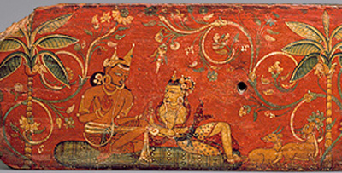
Dushyanta gives the ring to Shakuntala (Nepal, ca. 1050 AD)
(Metropolitan Museum, New York)
Soon King Dushyanta had to go back to the city. He gave Shakuntala his ring, and said he would send for her soon. But while she was waiting, Shakutala was accidentally rude to a visiting magician. The magician cursed her. He said that whoever she was dreaming of would forget all about her! But then he felt sorry for her, and changed his curse so that King Dushyanta would remember her again if he saw the ring. But the magician didn't tell Shakutala anything about the curse.
Well, King Dushyanta had forgotten all about his wife Shakuntala, because of the curse. So he never sent for her, while she gave birth to their son Bharata. Finally Shakuntala decided to go the city and look for her husband. But on the way there, her ring fell off into a river, and Shakuntala didn't even notice.
When Shakuntala arrived at King Dushyanta's palace, she was surprised and upset when her husband didn't even recognize her (because of the curse). Shakuntala went back to the forest and raised their son Bharata there, just the two of them all alone.
Meanwhile, a fisherman caught a fish and found the king's ring in its stomach. He took the ring to the palace, and as soon as King Dushyanta saw the ring, the curse was broken and he suddenly remembered all about Shakuntala. Dushyanta set off immediately for the forest to find his wife and son, and they all lived happily ever after.

