Stone Weights
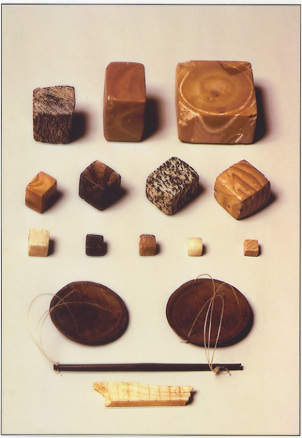
These are weights of various sizes and a scale. These weights were discovered near a large building located on the citadel, just south and west of the Great Bath. This building, which is made of mud bricks and measures 150 feet long and 75 feet wide, is referred to as the Granary.
Archeologists have also found bits of grain, such as wheat and barley, in the building ruins. This has led some of them to speculate that the building was used to store grain and also to house workers who crushed the grain into flour for trade. Because farmers outside the walls of Mohenjo-Daro usually had their own granaries, some archeologists think that grain stored within the citadel granary may have been collected as taxes. In addition, because of the presence of the weights, archeologists have speculated that merchants weighted their grain and used it like money to buy and sell goods.

The Great Bath
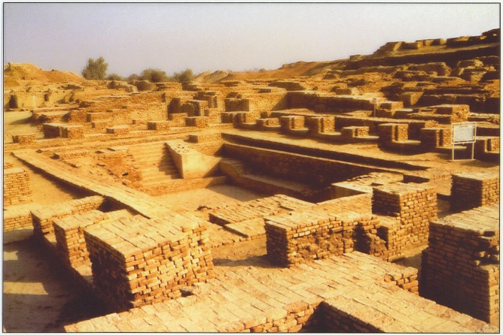
This is the ruins of the Great Bath in Mohenjo-Daro. Located on the citadel, this ruin contains at its center an 8-foot-deep, 39-foot-long, and 23-foot-wide rectangular bathing pool built from waterproofed brick.
The pool is surrounded by a series of small dressing rooms, one of which contains a well that supplied water to the bath. Used water was removed from the pool via a 6-foot-high drain that ran along the west side of the Great Bath.
The people of Mohenjo-Daro used the bath for hygienic purposes, and some archeologists theorize that the Great Bath might have also been used in religious rituals. To support this theory, archeologists point to the baths of later Hindu temples and the bathing rituals that remain an important part of modern Hinduism.

The Statue of Male Figure and Necklace
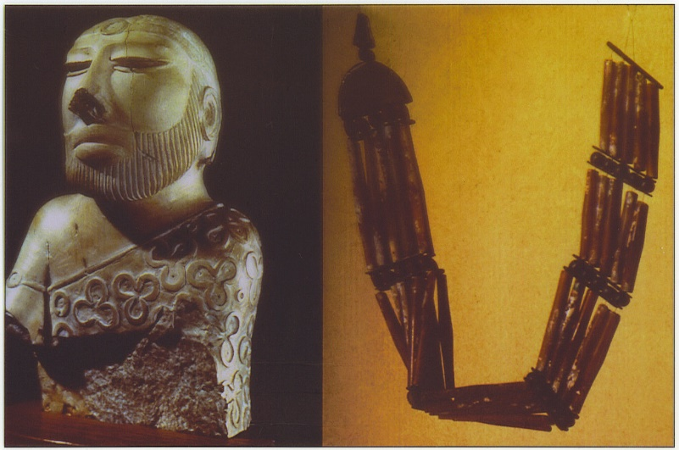
This is a male statuette and a necklace made of beads. Little is known about the appearance of men and women in Mohenjo-Daro. However, a 7-inch-high stone sculpture discovered in the lower city shows how men in Mohenjo-Daro might have looked and dressed. The figure's beard is short and neat, his upper lip is shaved clean, and his hair is tied with a band that hangs down his back to his shoulder. A patterned robe covers his left shoulder, while his right shoulder is bare. Archeologists once thought that this small statue was of a priest-king, but now they are uncertain whom it represents. Archeologists believe that some of the female statues found in Mojenjo-Daro are fertility Goddesses that might have been worshiped by the ancient Indians.
Many beautiful beads of blue lapis lazuli, red carnelian, and agate stones of all colors have been found throughout Mohenjo-Daro and were likely worn by the population's women. Holes drilled into the beads show that they were worn as necklaces, bracelets, earrings, finger rings, and other body decorations. Archeologists have found beads in such locations as the Great Bath, where bathers probably lost them, and in the lower city, where bead-makers may have dropped them in and around the kilns they used to make the beads.

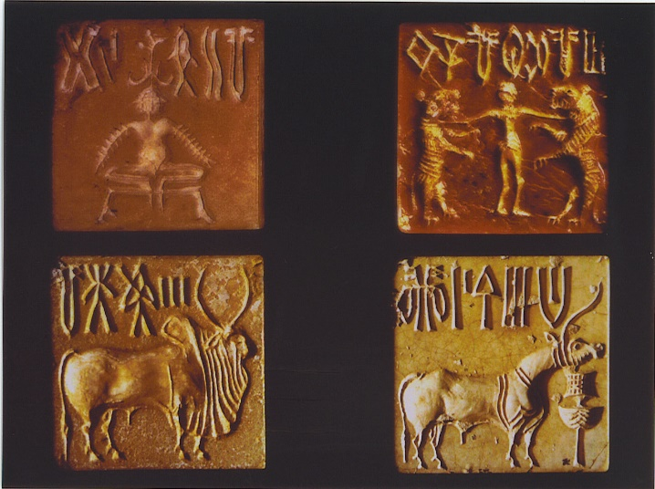
Four Seals
These are four seals engraved with various animals and writing. Seals, found in large numbers all over the Mohenjo-Daro site, were generally carved from a soft stone called steatite. Ranging from .75 to 1.75 inches in size, the seals are carved with pictographs (pictures or symbols used to represent an object, sound, or idea).
Over 400 different pictographs have been identified, but very few have been deciphered. Most seals depict animals, such as buffalo, humped bull, tiger, elephant, rhinoceros, fish, and crocodile. There are seals that depict a cross-legged figure, which some scholars believe is an early version of the Hindu God Shiva.
Many of the seals have a boss, or small loop, on the back, which leads archeologists to think that the people of Mohenjo-Daro may have worn them on a cord around their necks as amulets, charms worn to protect the wearer from harm or evil.
Archeologists have also speculated that the seals were pressed into wax to make a sort of tag, perhaps showing which merchants owned what goods.

The Sewer System
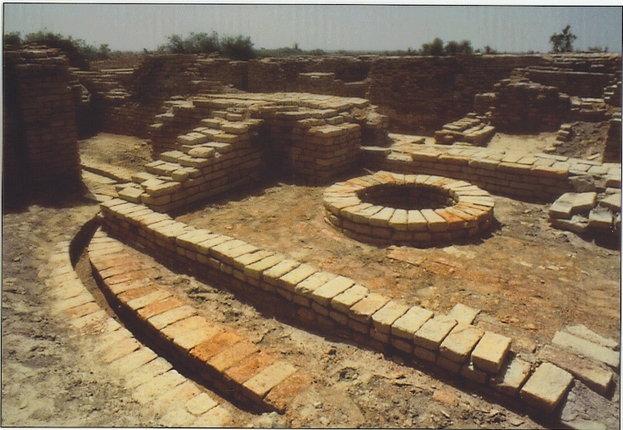
This is the ruins of the sewer system showing some clay pipes and a well. Mohenjo-Daro's "chief glory" was a complex system of drains that ran throughout the city. According to one scholar, "only the Romans, more than two thousand years later, had a comparable drainage system."
Clay pipes carried dirty, used water from buildings on the citadel and homes in the lower city to the main sewer system that ran along the city streets. The water and other sewage was emptied into the Indus River. This sewer system made it possible for both the rich and the poor to have bathrooms in their homes.
Also located throughout the city are deep wells, in which the people of Mohenjo-Daro stored their water.

Homes
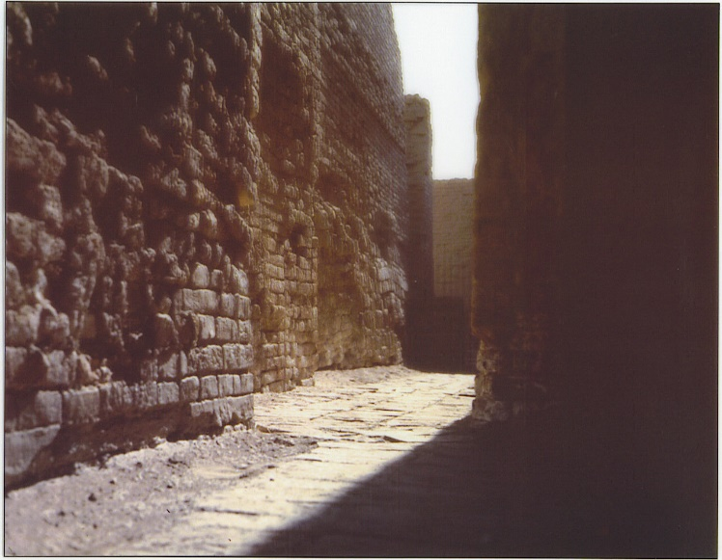
This is the ruins of several homes alongside a narrow alley. Most of Mohenjo-Daro's peoples lived in the lower city, an area to the east of the citadel and three times its size. Rows and rows of flat-roofed, two-story, mud-brick houses lined the streets. The houses' windows were typically located on the second floor, were narrow, and were covered with screens made of a hard clay called terra-cotta or a translucent mineral called alabaster. The houses' outside walls faced narrow alleys and their inside walls faced an open courtyard. Many of the houses had indoor bathrooms that drained into the main sewer system that ran throughout the city streets. Archeologists have excavated houses containing one room and houses containing more than a dozen rooms. They have speculated that the one-room houses belonged to the poorer citizens of Mohenjo-Daro and the multiroom houses to the wealthier.

Games
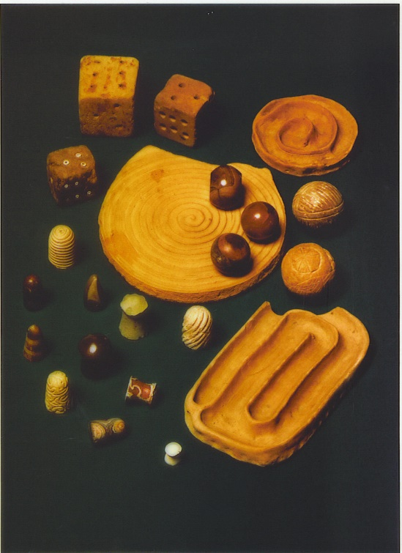
This picture shows dice, carved pawns, balls carved of stone, and clay tracks. Archeologists have unearthed various artifacts at Mohenjo-Daro that they speculate were used to play games. Their findings include dice; solid stone boards; and small, carved "pawns" that they speculate might have been used to play an ancient form of chess. As evidence for this, archeologists point to an ancient Indian work written in the sixth century B.C.E., the Bhavishya Purana. The Purana describes a war game played with dice and pawns that game historians believe is the predecessor to modern-day chess. The Purana refers to this game as Chaturanga, or "four parts." Archeologists have also found toys consisting of grooved tracks made of baked clay and balls carved out of stone.

Clay Figurine
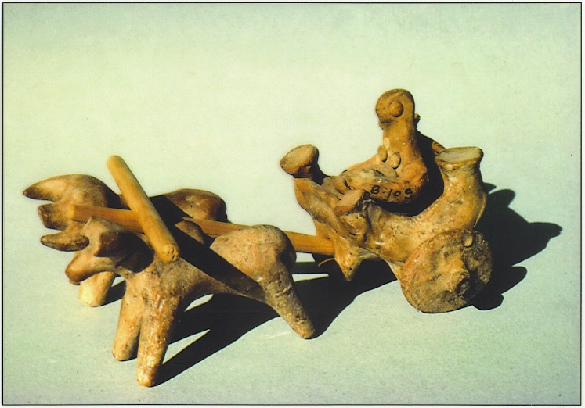
This is an assembly of clay figures that includes a pottery-filled cart pulled by two bulls. This model is made of terra-cotta. Archeologists believe the model shows how farm goods might have been transported from the fields outside of Mohenjo-Daro to the city market. These goods probably included wheat, barley, cotton, rice, melons, peas, sesame seeds, and dates. Children may have played with toy-like terra-cotta models such as this one, along with other small clay figures of humans and animals that have been found at the Mohenjo-Daro site.

